Airflow Pipeline Report

Objective
The objective of this project is to design and implement an ETL (Extract, Transform, Load) pipeline using Apache Airflow. The pipeline processes a dataset (Netflix titles dataset), performs data cleaning and transformation, and generates insights through Exploratory Data Analysis (EDA).

Tools & Technologies Used
- Python
- Apache Airflow
- Pandas & NumPy
- Linux Environment
- Airflow Scheduler & Web UI

Dataset Description

Column Name | Description | Example Values | Data Type
show_id | Unique identifier for each record | S1, S2, S5000 | String (object)
type | Type of content | Movie, TV Show | Categorical
title | Name of the content | Breaking Bad, The Irishman | String (object)
director | Director of the content | Martin Scorsese, Unknown | String (object)
cast | Actors involved | Actor1, Actor2 | String → List
country | Country of production | United States, India | Categorical
date_added | Date added to Netflix | 2019-09-09 | Datetime
release_year | Year of release | 2019, 2020 | Integer
rating | Content maturity rating | PG, TV-MA | Categorical
duration | Duration of content | 90 min, 2 Seasons | String (object)
listed_in | Genre/category | Drama, Thriller | String → List
description | Summary of content | A story about... | Text (string)

ETL Pipeline Overview
The Airflow pipeline is designed to automate the end-to-end ETL process for the Netflix dataset in a structured and scalable manner. It enables seamless ingestion of raw data, followed by systematic cleaning, transformation, and storage, eliminating the need for manual intervention.
The workflow is organized into distinct tasks - Extract, Transform, Load, and EDA - and orchestrated using Apache Airflow’s DAG architecture. Each task is executed in a predefined sequence, ensuring data integrity, consistency, and reliable processing throughout the pipeline.

4.1 Extract
- Reads dataset from CSV file
- Counts total records
- Passes data to next stage
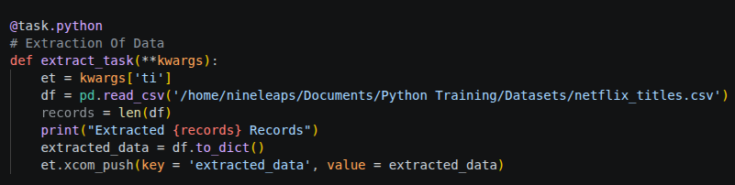

4.2 Transform (Data Cleaning & Processing)

- Data Cleaning
  - Removed duplicate records to avoid redundancy
  - Handled missing values:
    - director → replaced with "Unknown"
    - cast → replaced with "Not Available"
    - country → replaced with "Unknown”
- Data Standardization
  - Converted text columns to consistent formats:
    - show_id, type, country, rating → UPPERCASE
    - title → Title Case
  - Ensured all text fields are properly typed as strings
- Data Type Conversion
  - Converted release_year → numeric format
  - Ensured proper data types for analysis
- Feature Engineering
  - Created new columns from duration:
    - duration_min → duration in minutes (for movies)
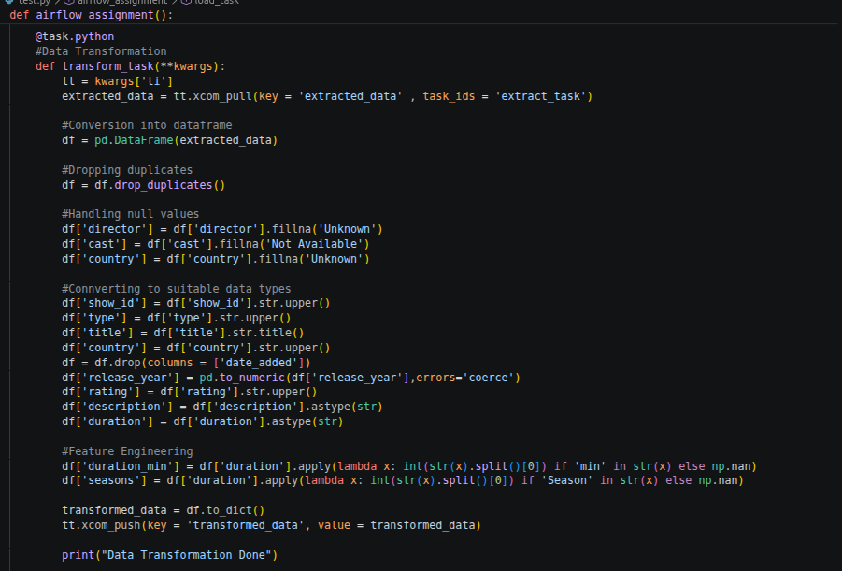
    - seasons → number of seasons (for TV shows)

4.3 Load
- Transformed data is saved as a CSV file
- Output stored in specified path:
/home/nineleaps/airflow/logs/data/transformed_netflix_titles.csv
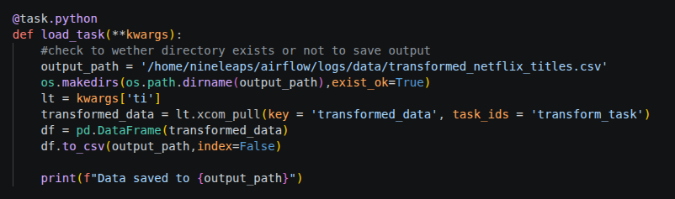

4.4 Exploratory Data Analysis
Performed analysis to generate insights:
- Top countries producing content
- Distribution of Movies vs TV Shows
- Most popular genres
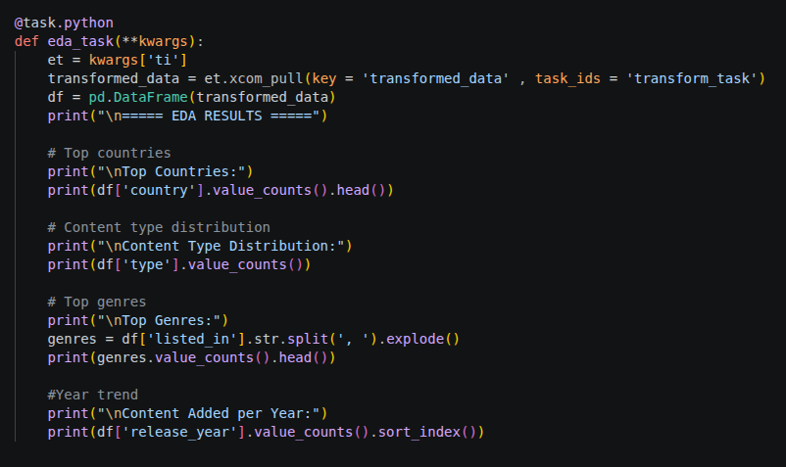
- Year-wise content addition trend

Airflow DAG Structure

DAG Structure:
Extract → Transform → Load → EDA

Features Used:
- @dag decorator
- @task.python
- Task dependencies using >>
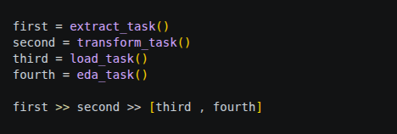
- XCom for data passing

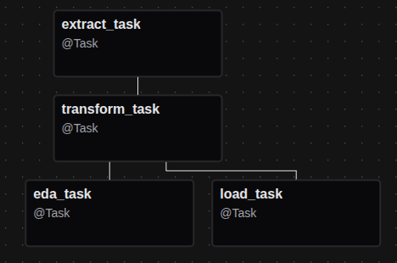

Output

- Extract Task
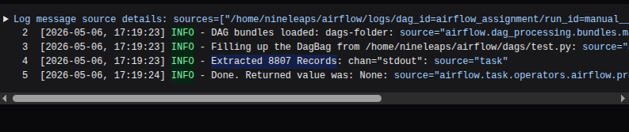
- Transform Task

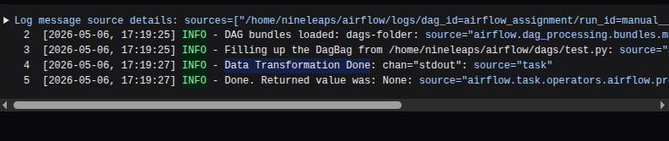

- Load Task
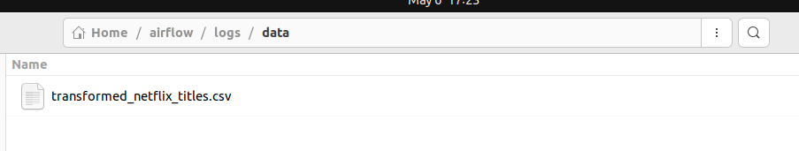
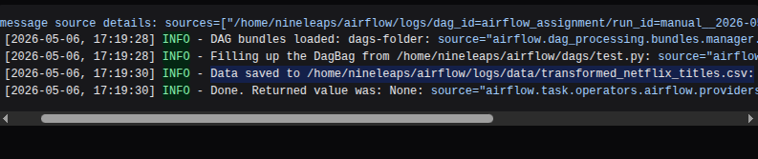

- EDA Analysis

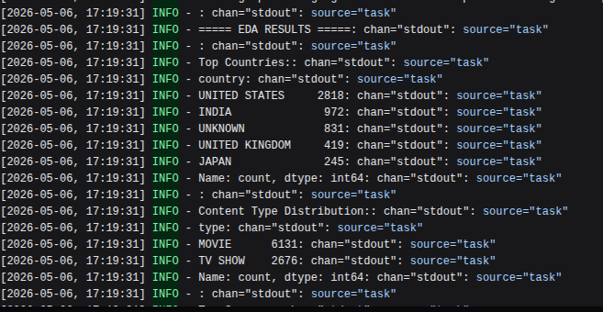
- Task Logs
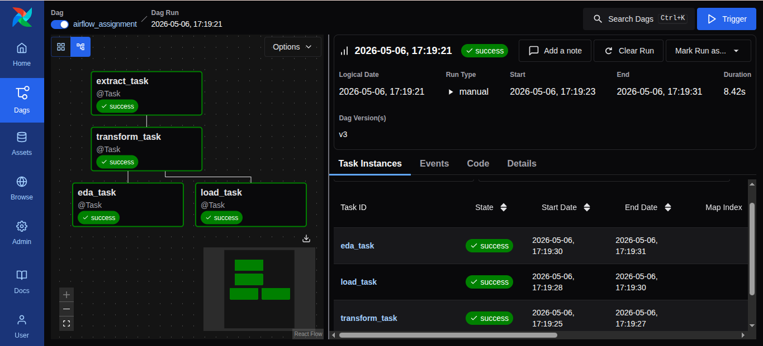

Conclusion
This project demonstrates how Apache Airflow can be used to automate a complete ETL pipeline. The dataset was successfully extracted, cleaned, analyzed, and stored using a structured workflow.
The use of Airflow made the pipeline scalable, reusable, and easy to monitor. This approach is widely used in real-world data engineering applications.

